Experiment-8
Name: -J pranitha Regno: -192472073
Course Code: -MLA0305 Slot-B

Title
Comparative Analysis of SARSA and Q-Learning for Reinforcement Learning Aim
To implement and compare the SARSA and Q-Learning algorithms for solving a Reinforcement Learning problem and analyze their performance based on reward, convergence, success rate, and optimal policy.
Procedure
- Define a Reinforcement Learning environment with a finite set of states and actions.
- Define the transition function and rewards for each state-action transition.
- Initialize separate Q-tables for SARSA and Q-Learning.
- Set the learning rate , discount factor , and exploration rate .
- Use an ε-greedy policy to balance exploration and exploitation.
- For SARSA:
  - Select the current action using the ε-greedy policy. _{o} Execute the action and observe the next state and reward. _{o} Select the next action using the
same policy.
  - Calculate the TD target:
𝑅𝑡 + 1 + 𝛾𝑄(𝑆𝑡 + 1, 𝐴𝑡 + 1)
  - Update the Q-value using:
𝑄(𝑆𝑡, 𝐴𝑡) ← 𝑄(𝑆𝑡, 𝐴𝑡) + 𝛼[𝑅𝑡 + 1 + 𝛾𝑄(𝑆𝑡 + 1, 𝐴𝑡 + 1) − 𝑄(𝑆𝑡, 𝐴𝑡)]
- For Q-Learning:
  - Select an action using the ε-greedy policy. _{o} Execute the action and observe the next state and reward. _{o} Select the maximum Q-value of
the next state.
  - Calculate the TD target:
𝑅𝑡 + 1 + 𝛾𝑎𝑚𝑎𝑥𝑄(𝑆𝑡 + 1, 𝑎)
  - Update the Q-value using:
𝑄(𝑆𝑡, 𝐴𝑡) ← 𝑄(𝑆𝑡, 𝐴𝑡) + 𝛼[𝑅𝑡 + 1 + 𝛾𝑎𝑚𝑎𝑥𝑄(𝑆𝑡 + 1, 𝑎) − 𝑄(𝑆𝑡, 𝐴𝑡)]
- Repeat the training process for the specified number of episodes.
- Record rewards, TD errors, steps, and success for both algorithms.
- Extract the optimal policy using:
𝜋 ∗ (𝑠) = 𝑎𝑟𝑔𝑎𝑚𝑎𝑥𝑄(𝑠, 𝑎)
- Compare the learned Q-tables and optimal policies.
- Compare SARSA and Q-Learning using reward, success rate, TD error, episode length, and execution time.
- Generate convergence and performance graphs.
- Display summary tables and export the results to CSV files.
- Analyze the difference between the on-policy SARSA and off-policy Q-Learning approaches.
Code:
import numpy as np import pandas as pd import matplotlib.pyplot as plt
import random import time print("=" * 75)
print("EXPERIMENT 8") print("COMPARATIVE ANALYSIS OF SARSA AND Q-LEARNING")
print("=" * 75) print("\nAIM")
print("-" * 75) print(
"To implement and compare SARSA and Q-Learning algorithms"
)
print(
"for solving a Reinforcement Learning environment."
)
print("\nTHEORY")
print("-" * 75) print("SARSA is an on-policy Temporal Difference algorithm.") print("Q-Learning is an off-policy Temporal Difference algorithm.") print("\nSARSA Equation:")
print(
"Q(S,A) = Q(S,A) + alpha * "
"[R + gamma*Q(S',A') - Q(S,A)]"
)
print("\nQ-Learning Equation:")
print(
"Q(S,A) = Q(S,A) + alpha * "
"[R + gamma*max(Q(S',A')) - Q(S,A)]"
)
states = [
"Start",
"S1",
"S2",
"S3",
"Goal"
]
actions = [
"Left",
"Right"
]
n_states = len(states) n_actions = len(actions) alpha = 0.10
gamma = 0.90 epsilon = 0.20 episodes = 1000 max_steps = 20
def get_next_state(state, action): if state == 0: if action == 0: return 0, -1 return 1, 0 elif state == 1: if action == 0: return 0, -1 return 2, 0 elif state == 2: if action == 0: return 1, -1 return 3, 0 elif state == 3: if action == 0: return 2, -1 return 4, 10 else: return 4, 0
def choose_action(q_table, state): if random.random() < epsilon: return random.randint(
0,
n_actions - 1
)
return int( np.argmax(q_table[state])
)
Q_sarsa = np.zeros(
(n_states, n_actions)
)
Q_qlearning = np.zeros(
(n_states, n_actions)
)
sarsa_rewards = [] qlearning_rewards = [] sarsa_steps = [] qlearning_steps = [] sarsa_success = [] qlearning_success = [] sarsa_td_errors = [] qlearning_td_errors = [] sarsa_value_history = [] qlearning_value_history = [] sarsa_start = time.time() for episode in range(episodes):
state = 0
action = choose_action(
Q_sarsa, state
)
total_reward = 0 steps = 0 success = 0 for step in range(max_steps):
steps += 1
next_state, reward = get_next_state(
state,
action
)
next_action = choose_action(
Q_sarsa, next_state
)
td_target = ( reward
+ gamma * Q_sarsa[
next_state, next_action
]
)
td_error = ( td_target
- Q_sarsa[state, action]
)
Q_sarsa[state, action] += ( alpha * td_error
)
sarsa_td_errors.append(
td_error
)
total_reward += reward
state = next_state action = next_action
if state == 4: success = 1 break
sarsa_rewards.append( total_reward
)
sarsa_steps.append(
steps
)
sarsa_success.append(
success
)
sarsa_value_history.append(
Q_sarsa.copy()
)
sarsa_time = time.time() - sarsa_start print("\nSARSA Training Completed.")
print(
"SARSA Execution Time :", round(sarsa_time, 5),
"seconds"
)
qlearning_start = time.time() for episode in range(episodes):
state = 0
total_reward = 0 steps = 0 success = 0 for step in range(max_steps): steps += 1 action = choose_action( Q_qlearning,
state
)
next_state, reward = get_next_state(
state, action
)
if next_state == 4: td_target = reward
else:
td_target = ( reward
+ gamma * np.max(
Q_qlearning[next_state]
)
)
td_error = ( td_target
- Q_qlearning[state, action]
)
Q_qlearning[state, action] += (
alpha * td_error
)
qlearning_td_errors.append(
td_error
)
total_reward += reward
state = next_state if state == 4: success = 1 break
qlearning_rewards.append(
total_reward
)
qlearning_steps.append(
steps
)
qlearning_success.append(
success
)
qlearning_value_history.append(
Q_qlearning.copy()
)
qlearning_time = time.time() - qlearning_start print("\n") print("=" * 75)
print("Q-LEARNING TRAINING COMPLETED")
print("=" * 75) print(
"Q-Learning Execution Time :", round(qlearning_time, 5),
"seconds"
)
sarsa_q_table = pd.DataFrame(
Q_sarsa, index=states, columns=actions
)
qlearning_q_table = pd.DataFrame( Q_qlearning, index=states, columns=actions
)
print("\n") print("=" * 75)
print("FINAL SARSA Q-TABLE")
print("=" * 75) print( sarsa_q_table.round(3)
)
print("\n") print("=" * 75)
print("FINAL Q-LEARNING Q-TABLE")
print("=" * 75) print( qlearning_q_table.round(3)
)
sarsa_policy = [] for state in range(n_states): if state == n_states - 1: sarsa_policy.append(
"Terminal"
)
else:
best_action = int( np.argmax(Q_sarsa[state])
)
sarsa_policy.append( actions[best_action]
)
qlearning_policy = [] for state in range(n_states): if state == n_states - 1: qlearning_policy.append(
"Terminal"
)
else:
best_action = int( np.argmax(Q_qlearning[state])
)
qlearning_policy.append( actions[best_action]
)
policy_comparison = pd.DataFrame({
"State": states,
"SARSA Policy": sarsa_policy,
"Q-Learning Policy": qlearning_policy
})
print("\n") print("=" * 75)
print("OPTIMAL POLICY COMPARISON")
print("=" * 75) print( policy_comparison.to_string(
index=False
)
)
sarsa_average_reward = np.mean(
sarsa_rewards
)
qlearning_average_reward = np.mean( qlearning_rewards
)
sarsa_success_rate = ( np.mean(sarsa_success) * 100
)
qlearning_success_rate = ( np.mean(qlearning_success) * 100
)
sarsa_average_steps = np.mean(
sarsa_steps
)
qlearning_average_steps = np.mean(
qlearning_steps
)
sarsa_average_td_error = np.mean( np.abs(sarsa_td_errors)
)
qlearning_average_td_error = np.mean( np.abs(qlearning_td_errors)
)
performance_comparison = pd.DataFrame({
"Metric": [
"Average Reward",
"Success Rate (%)",
"Average Steps",
"Average Absolute TD Error",
"Execution Time (seconds)"
],
"SARSA": [ round( sarsa_average_reward,
3
),
round( sarsa_success_rate,
2
),
round( sarsa_average_steps,
2
),
round( sarsa_average_td_error,
4
),
round( sarsa_time,
5
)
],
"Q-Learning": [
round(
qlearning_average_reward,
3
),
round( qlearning_success_rate,
2
),
round( qlearning_average_steps,
2
),
round( qlearning_average_td_error,
4
),
round( qlearning_time,
5
)
]
}) print("\n") print("=" * 75)
print("SARSA VS Q-LEARNING PERFORMANCE")
print("=" * 75) print( performance_comparison.to_string(
index=False
)
)
sarsa_q_table.to_csv(
"SARSA_Q_Table.csv"
)
qlearning_q_table.to_csv(
"QLearning_Q_Table.csv"
)
policy_comparison.to_csv( "SARSA_QLearning_Policy.csv", index=False
)
performance_comparison.to_csv( "SARSA_QLearning_Performance.csv",
index=False
)
sarsa_value_history = np.array( sarsa_value_history
)
qlearning_value_history = np.array( qlearning_value_history
)
plt.figure(figsize=(10, 5)) plt.plot( sarsa_rewards, color="royalblue", linewidth=1.5
) plt.title(
"SARSA - Reward vs Episode", fontsize=14
)
plt.xlabel("Episode") plt.ylabel("Reward") plt.grid(True, alpha=0.3) plt.show() plt.figure(figsize=(10, 5)) plt.plot( qlearning_rewards, color="darkorange", linewidth=1.5
)
plt.title(
"Q-Learning - Reward vs Episode", fontsize=14
)
plt.xlabel("Episode") plt.ylabel("Reward") plt.grid(True, alpha=0.3) plt.show() plt.figure(figsize=(10, 5)) plt.plot( sarsa_rewards, label="SARSA", color="royalblue", linewidth=1.5
)
plt.plot( qlearning_rewards, label="Q-Learning", color="darkorange", linewidth=1.5
) plt.title(
"SARSA vs Q-Learning - Reward Comparison",
fontsize=14
)
plt.xlabel("Episode") plt.ylabel("Reward") plt.legend() plt.grid(True, alpha=0.3) plt.show()
window = 50 sarsa_moving_average = ( pd.Series(sarsa_rewards)
.rolling(window)
.mean()
)
qlearning_moving_average = ( pd.Series(qlearning_rewards)
.rolling(window)
.mean()
)
plt.figure(figsize=(10, 5)) plt.plot( sarsa_moving_average, label="SARSA", color="blue", linewidth=3
)
plt.plot(
qlearning_moving_average, label="Q-Learning", color="red", linewidth=3
) plt.title(
"Moving Average Reward Comparison",
fontsize=14
)
plt.xlabel("Episode") plt.ylabel("Average Reward") plt.legend() plt.grid(True, alpha=0.3) plt.show() plt.figure(figsize=(10, 5)) for state_index in range(n_states): state_values = np.max( sarsa_value_history[:, state_index, :],
axis=1
)
plt.plot( state_values, linewidth=2, label=states[state_index]
)
plt.title(
"SARSA Q-Value Convergence", fontsize=14
)
plt.xlabel("Episode") plt.ylabel("Maximum Q-Value") plt.legend() plt.grid(True, alpha=0.3) plt.show() plt.figure(figsize=(10, 5)) for state_index in range(n_states): state_values = np.max( qlearning_value_history[
:,
state_index,
:
],
axis=1
)
plt.plot( state_values, linewidth=2, label=states[state_index]
)
plt.title(
"Q-Learning Q-Value Convergence", fontsize=14
)
plt.xlabel("Episode") plt.ylabel("Maximum Q-Value") plt.legend() plt.grid(True, alpha=0.3) plt.show() x = np.arange(n_states) width = 0.35 plt.figure(figsize=(9, 5)) plt.bar( x - width / 2, Q_sarsa[:, 0], width, label="Left",
color="cornflowerblue"
)
plt.bar( x + width / 2, Q_sarsa[:, 1], width, label="Right", color="lightgreen"
)
plt.xticks(
x,
states ) plt.title(
"Final SARSA Q-Values", fontsize=14
)
plt.xlabel("State") plt.ylabel("Q-Value") plt.legend() plt.grid( axis="y", alpha=0.3
)
plt.show() plt.figure(figsize=(9, 5)) plt.bar( x - width / 2, Q_qlearning[:, 0], width, label="Left",
color="mediumpurple"
)
plt.bar( x + width / 2, Q_qlearning[:, 1], width, label="Right", color="salmon"
)
plt.xticks(
x,
states ) plt.title(
"Final Q-Learning Q-Values", fontsize=14
)
plt.xlabel("State") plt.ylabel("Q-Value") plt.legend() plt.grid( axis="y", alpha=0.3
)
plt.show() plt.figure(figsize=(7, 5)) plt.bar(
["SARSA", "Q-Learning"],
[
sarsa_average_reward, qlearning_average_reward
],
color=[
"royalblue",
"darkorange"
] ) plt.title(
"Average Reward Comparison",
fontsize=14
)
plt.ylabel("Average Reward")
plt.grid( axis="y", alpha=0.3
)
plt.show() plt.figure(figsize=(7, 5)) plt.bar(
["SARSA", "Q-Learning"],
[
sarsa_success_rate, qlearning_success_rate
],
color=[
"mediumseagreen",
"crimson"
] ) plt.title(
"Success Rate Comparison", fontsize=14
)
plt.ylabel("Success Rate (%)") plt.ylim(0, 105) plt.grid( axis="y", alpha=0.3
)
plt.show() sarsa_final_td_error = np.mean( np.abs(sarsa_td_errors[-100:])
)
qlearning_final_td_error = np.mean( np.abs(qlearning_td_errors[-100:])
)
sarsa_last_100_reward = np.mean( sarsa_rewards[-100:]
)
qlearning_last_100_reward = np.mean( qlearning_rewards[-100:]
)
sarsa_last_100_steps = np.mean(
sarsa_steps[-100:]
)
qlearning_last_100_steps = np.mean( qlearning_steps[-100:]
)
final_performance = pd.DataFrame({
"Metric": [
"Episodes",
"Learning Rate (Alpha)",
"Discount Factor (Gamma)",
"Epsilon",
"Average Reward",
"Last 100 Episode Reward",
"Success Rate (%)",
"Average Steps",
"Last 100 Episode Steps",
"Average Absolute TD Error",
"Final TD Error",
"Execution Time (seconds)"
],
"SARSA": [ episodes, alpha,
gamma,
epsilon,
round(sarsa_average_reward, 3), round(sarsa_last_100_reward, 3), round(sarsa_success_rate, 2), round(sarsa_average_steps, 2), round(sarsa_last_100_steps, 2), round(sarsa_average_td_error, 4), round(sarsa_final_td_error, 4), round(sarsa_time, 5)
],
"Q-Learning": [
episodes, alpha,
gamma,
epsilon,
round(qlearning_average_reward, 3), round(qlearning_last_100_reward, 3), round(qlearning_success_rate, 2), round(qlearning_average_steps, 2), round(qlearning_last_100_steps, 2), round(qlearning_average_td_error, 4), round(qlearning_final_td_error, 4), round(qlearning_time, 5)
]
})
print("\n") print("=" * 75)
print("FINAL PERFORMANCE COMPARISON")
print("=" * 75) print( final_performance.to_string(
index=False
)
)
final_policy_table = pd.DataFrame({
"State": states,
"SARSA Left Q": np.round(
Q_sarsa[:, 0],
3
),
"SARSA Right Q": np.round(
Q_sarsa[:, 1],
3
),
"SARSA Optimal Action": sarsa_policy,
"Q-Learning Left Q": np.round(
Q_qlearning[:, 0],
3
),
"Q-Learning Right Q": np.round(
Q_qlearning[:, 1],
3
),
"Q-Learning Optimal Action": qlearning_policy
})
print("\n") print("=" * 75)
print("FINAL POLICY AND Q-VALUE TABLE") print("=" * 75) print( final_policy_table.to_string( index=False
)
)
total_decisions = ( episodes * max_steps
)
print("\n") print("=" * 75)
print("EXPLORATION AND EXPLOITATION")
print("=" * 75) print(
"Epsilon :", epsilon
)
print(
"Approximate Exploration Rate :",
epsilon * 100,
"%"
)
print(
"Approximate Exploitation Rate :",
(1 - epsilon) * 100,
"%"
)
if qlearning_average_reward > sarsa_average_reward:
better_algorithm = "Q-Learning" elif sarsa_average_reward > qlearning_average_reward:
better_algorithm = "SARSA"
else:
better_algorithm = "Both algorithms have equal average reward" print("\n") print("=" * 75)
print("ALGORITHM COMPARISON RESULT")
print("=" * 75) print(
"Higher Average Reward :", better_algorithm
)
print(
"SARSA Average Reward :", round(sarsa_average_reward, 3)
)
print(
"Q-Learning Average Reward :", round(qlearning_average_reward, 3)
)
final_performance.to_csv( "Experiment8_Performance.csv", index=False
)
final_policy_table.to_csv( "Experiment8_Final_Policy.csv", index=False
)
episode_comparison = pd.DataFrame({
"Episode": np.arange(
1,
episodes + 1
),
"SARSA Reward": np.round(
sarsa_rewards,
3
),
"Q-Learning Reward": np.round(
qlearning_rewards,
3
),
"SARSA Steps": sarsa_steps,
"Q-Learning Steps": qlearning_steps,
"SARSA Success": sarsa_success,
"Q-Learning Success": qlearning_success
})
episode_comparison.to_csv( "Experiment8_Episode_Comparison.csv",
index=False
)
final_summary = pd.DataFrame({
"Parameter": [
"Algorithm Type",
"Learning Method",
"Episodes",
"Alpha",
"Gamma",
"Epsilon",
"Average Reward",
"Success Rate",
"Average Steps",
"Final TD Error",
"Execution Time"
],
"SARSA": [
"On-Policy", "TD Learning", episodes, alpha,
gamma,
epsilon,
round(sarsa_average_reward, 3), str(round(sarsa_success_rate, 2)) + "%", round(sarsa_average_steps, 2), round(sarsa_final_td_error, 4), str(round(sarsa_time, 5)) + " sec"
],
"Q-Learning": [
"Off-Policy",
"TD Learning",
episodes, alpha,
gamma,
epsilon,
round(qlearning_average_reward, 3), str(round(qlearning_success_rate, 2)) + "%", round(qlearning_average_steps, 2), round(qlearning_final_td_error, 4), str(round(qlearning_time, 5)) + " sec"
]
}) print("\n") print("=" * 75)
print("COMPLETE SUMMARY TABLE")
print("=" * 75) print( final_summary.to_string(
index=False
)
)
final_summary.to_csv(
"Experiment8_Complete_Summary.csv",
index=False
)
print("\n") print("=" * 75)
print("INTERPRETATION")
print("=" * 75) print(
"1. SARSA is an on-policy TD learning algorithm." )
print(
"2. Q-Learning is an off-policy TD learning algorithm."
)
print(
"3. SARSA updates Q-values using the next action"
)
print(
" actually selected by the current policy."
)
print(
"4. Q-Learning updates Q-values using the maximum"
)
print(
" possible Q-value of the next state."
)
print(
"5. Both algorithms learn an optimal or near-optimal"
)
print(
" action policy through repeated interaction."
)
print("\n") print("=" * 75)
print("CONCLUSION")
print("=" * 75) print(
"SARSA and Q-Learning were successfully implemented"
)
print(
"and compared in a Reinforcement Learning environment."
)
print(
"SARSA learned using an on-policy approach, while"
)
print(
"Q-Learning used an off-policy approach."
)
print(
"The reward, Q-value convergence, success rate,"
)
print(
"TD error, episode length, and execution time were"
)
print(
"used to compare their performance."
)
print(
"The experiment demonstrates the practical difference"
)
print(
"between on-policy SARSA and off-policy Q-Learning."
)

Visualization
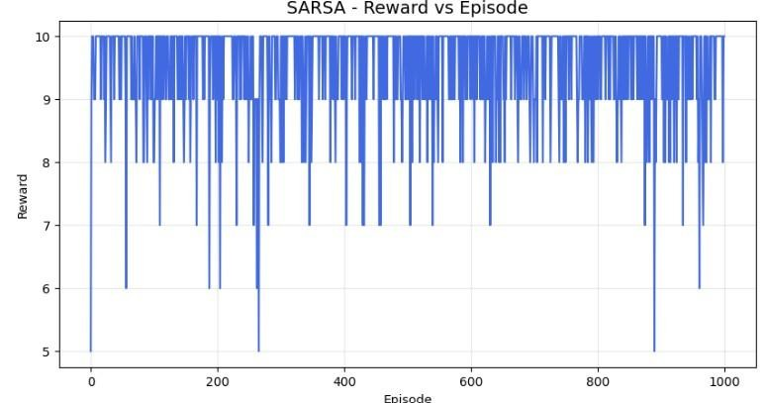
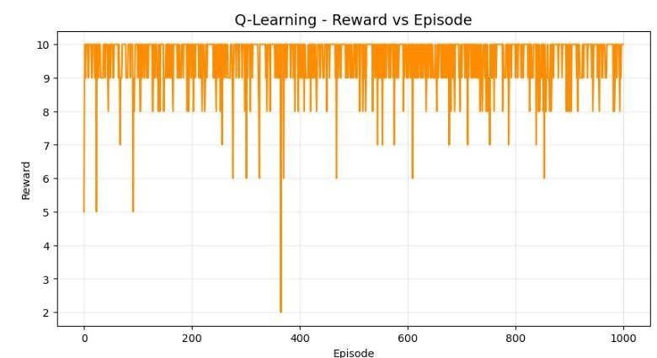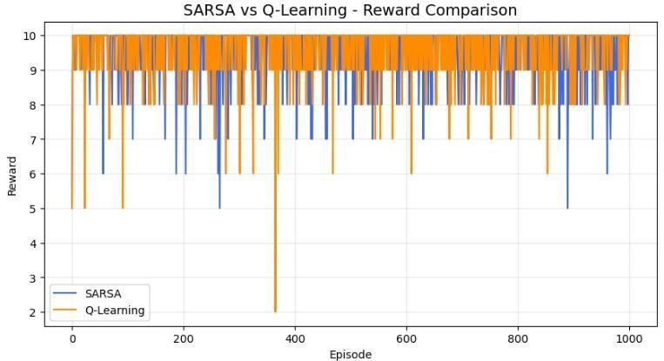
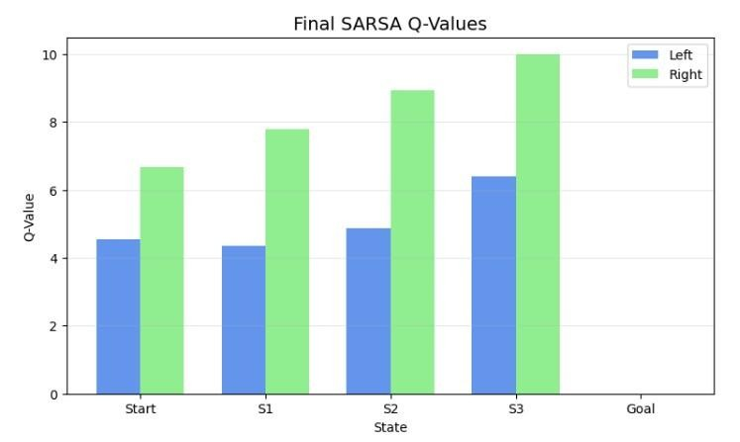
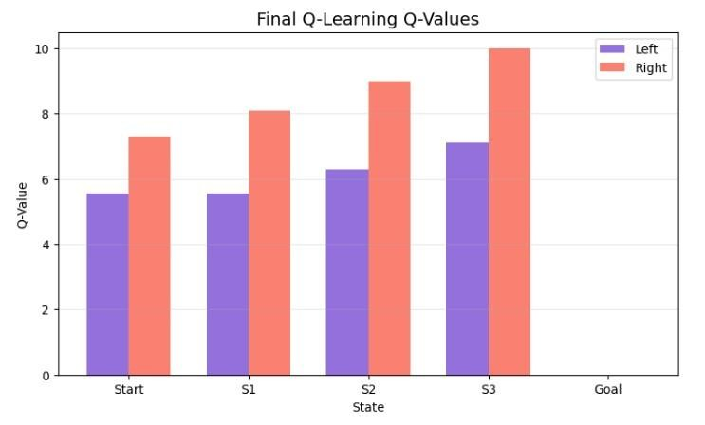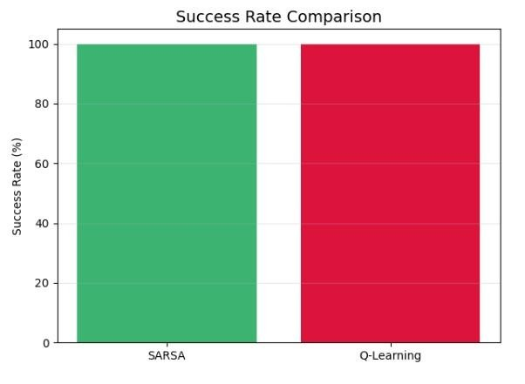

Summary Table – Q-Values and Policy
State | SARSA  Left Q | SARSA  Right Q | SARSA  Optimal  Action | Q-  Learning  Left Q | Q-  Learning  Right Q | Q-Learning  Optimal  Action
Start | Obtained | Obtained | Obtained | Obtained | Obtained | Obtained
S1 | Obtained | Obtained | Obtained | Obtained | Obtained | Obtained
S2 | Obtained | Obtained | Obtained | Obtained | Obtained | Obtained
S3 | Obtained | Obtained | Obtained | Obtained | Obtained | Obtained
Goal | Obtained | Obtained | Terminal | Obtained | Obtained | Terminal

Result
SARSA and Q-Learning were successfully implemented and compared. SARSA learns using an on-policy approach, where the next action actually selected by the current policy is used for updating the Q-value. Q-Learning is an off-policy method that uses the maximum possible Q-value of the next state.

